**CS 6314 Final Project Report**

**Food Product**

***Team 6***

|  |  |  |  |
| --- | --- | --- | --- |
| **Member** | **Net ID** | **Section** | **Responsibilities** |
| Yiqun Lu | yxl190059 | 001 | Take responsible for the style design and aesthetic guarantee of the entire website.  Mainly work on front-end design and implement for main page (search, filter), administrator interface, favorite, shopping cart, check out.  Responsible for the connection and debugging for front-end and back-end.  Took part in database design. |
| Chaoran Li | cxl190012 | 002 | Responsible for back-end coding and desing.  Mainly work on fetching data from database and providing api for front-end.  Cooperate with team mates to connect our code in the whole project.  Took part in group meeting and debugging for front-end and back-end. |
| Yifan Zhao | yxz190029 | 002 | Database design and implement.  Front-end design and implement for user sign up and sign in, user information, order history.  Responsible for project report writing and product information editing.  Took part in database design. |

***December 6, 2020***

**1．Project Title**

Food Products

**2．Name for the Website**

Food Products

**3. Project Description**

This website is designed for a dessert shop. We provide fresh desserts and drinks for customers. We have three kinds of users, guest, customer and admin.

For all three kinds users, they can browse the products in main page, click the product to enter the product details page to browse the product information. We use paging strategy to make our interface simple and elegant.

Users can complete the partial search on product name and filter product by category. Also, we achieve keyword and category combined filters for searching result. The searching result show dynamically on page. They can also use favorite to mark their ideal product even for guests.

We save all purchase related functions including shopcart only for registered customers. For signup, we will ensure the username and email unique for every customer by AJAX. We use JQuery Validator to ensure the validation of input. For example, the password should be strong enough and the email should be valid email address. Customers can alse view their purchasing history.

When users need to complete the purchase, they need register an account and complete login. Users can modify user information after logging in, including basic account information, payment method, and mailing address. Customers start the purchase from their shopcart and they should fill their necessary information for purchase before payment issued.

Only admins can edit products. Admins can view products like customers, but we implement list, add, edit and remove API for them. to the shopping cart and modify the type and quantity of items in the shopping cart. If the required product inventory is insufficient or there is no purchase demand temporarily, users can add the required product to the favorite.

For the project requirement, we implement soft delete for remove. While removing, we clear its store and make it invisible. Besides, Admins can also upload and change the image for products. We provide preview function before save the change.

All passwords store in database are hashed with bcrypt, admin users can not directly see the password information of user. This technology is widely used in blockchain. Below is our hashed passwords.



**4. Database Design**

We use MySQL as database. Below is the relational schema for our database.

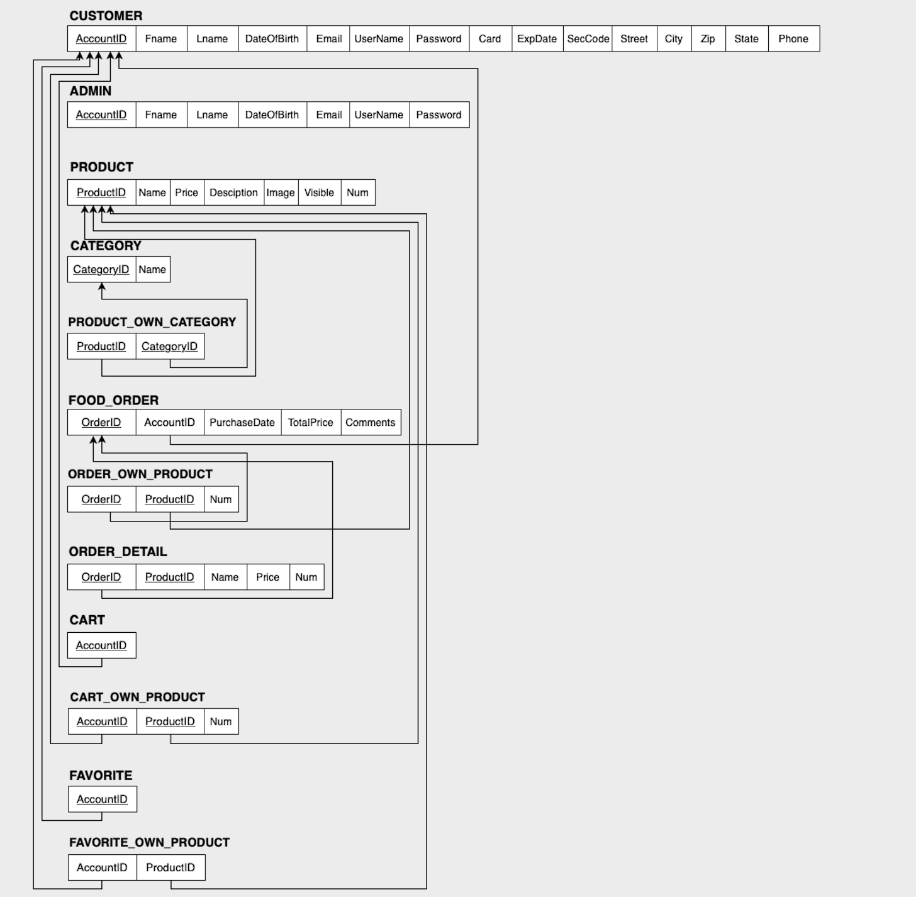

The whole database design is strictly followed by the 3NF standard. Information will be stored accordingly and separately to achieve the robustness and completeness.

For the delete product function of admin users, we implemented the soft delete in accordance with the project requirements. As long as a product is decided to be removed, we just clear the product inventory and change the visible attribute of the product to false, instead of directly deleting this record.

Below is the SQL statement we used to create database.

CREATE TABLE CUSTOMER (

    AccountID   INT,

    Fname       VARCHAR(25),

    Lname       VARCHAR(25),

    DateOfBirth VARCHAR(10),

    Email       VARCHAR(40) NOT NULL,

    UserName    VARCHAR(30) NOT NULL,

    Password    CHAR(60) NOT NULL,

    Card        VARCHAR(24),

    ExpDate     VARCHAR(5),

    SecCode     CHAR(3),

    Street      VARCHAR(100),

    City        VARCHAR(20),

    Zip         CHAR(5),

    State       CHAR(2),

    Phone       CHAR(10),

    PRIMARY KEY (AccountID)

);

CREATE TABLE ADMIN (

    AccountID   INT,

    Fname       VARCHAR(25),

    Lname       VARCHAR(25),

    DateOfBirth VARCHAR(10),

    Email       VARCHAR(40) NOT NULL,

    UserName    VARCHAR(30) NOT NULL,

    Password    CHAR(60) NOT NULL,

    Phone       CHAR(10),

    PRIMARY KEY (AccountID)

);

CREATE TABLE PRODUCT (

    ProductID   INT,

    Name        VARCHAR(50) NOT NULL,

    Price       DECIMAL(10, 2) NOT NULL,

    Description VARCHAR(200),

    Image       VARCHAR(50),

    Visible     TINYINT(1),

    Num         INT NOT NULL,

    PRIMARY KEY (ProductID)

);

CREATE TABLE CATEGORY (

    CategoryID  INT,

    Name        VARCHAR(30),

    PRIMARY KEY (CategoryID)

);

CREATE TABLE PRODUCT_OWN_CATEGORY (

    ProductID   INT,

    CategoryID  INT,

    PRIMARY KEY (ProductID, CategoryID),

    FOREIGN KEY (ProductID) REFERENCES PRODUCT(ProductID) ON DELETE CASCADE,

    FOREIGN KEY (CategoryID) REFERENCES CATEGORY(CategoryID) ON DELETE CASCADE

);

CREATE TABLE FOOD_ORDER (

    OrderID     INT,

    AccountID   INT NOT NULL,

    PurchaseDate    VARCHAR(10) NOT NULL,

    TotalPrice  DECIMAL(10, 2) NOT NULL,

    Comments    VARCHAR(200),

    PRIMARY KEY (OrderID),

    FOREIGN KEY (AccountID) REFERENCES CUSTOMER(AccountID) ON DELETE CASCADE

);

CREATE TABLE ORDER_OWN_PRODUCT (

    OrderID     INT,

    ProductID   INT,

    Num         INT NOT NULL,

    PRIMARY KEY (OrderID, ProductID),

    FOREIGN KEY (OrderID) REFERENCES FOOD_ORDER(OrderID) ON DELETE CASCADE,

    FOREIGN KEY (ProductID) REFERENCES PRODUCT(ProductID) ON DELETE CASCADE

);

CREATE TABLE ORDER_DETAIL (

    OrderID     INT,

    ProductID   INT,

    Name        VARCHAR(50) NOT NULL,

    Price       DECIMAL(10, 2) NOT NULL,

    Num         INT NOT NULL,

    PRIMARY KEY (OrderID, ProductID),

    FOREIGN KEY (OrderID) REFERENCES FOOD_ORDER(OrderID) ON DELETE CASCADE

);

CREATE TABLE CART (

    AccountID   INT NOT NULL,

    PRIMARY KEY (AccountID),

    FOREIGN KEY (AccountID) REFERENCES CUSTOMER(AccountID) ON DELETE CASCADE

);

CREATE TABLE CART_OWN_PRODUCT (

    AccountID   INT,

    ProductID   INT,

    Num     INT NOT NULL,

    PRIMARY KEY (AccountID, ProductID),

    FOREIGN KEY (AccountID) REFERENCES CUSTOMER(AccountID) ON DELETE CASCADE,

    FOREIGN KEY (ProductID) REFERENCES PRODUCT(ProductID) ON DELETE CASCADE

);

CREATE TABLE FAVORITE (

    AccountID   INT NOT NULL,

    PRIMARY KEY (AccountID),

    FOREIGN KEY (AccountID) REFERENCES CUSTOMER(AccountID) ON DELETE CASCADE

);

CREATE TABLE FAVORITE_OWN_PRODUCT (

    AccountID   INT,

    ProductID   INT,

    PRIMARY KEY (AccountID, ProductID),

    FOREIGN KEY (AccountID) REFERENCES CUSTOMER(AccountID) ON DELETE CASCADE,

    FOREIGN KEY (ProductID) REFERENCES PRODUCT(ProductID) ON DELETE CASCADE

);

**5. Languages and Frameworks for Implementation**

For the front-end, CSS, HTML and JavaScript is used to build up the general layout and appearance of the website. To make the website presented in a more beautiful and professional way, Bootstrap is used.

For the easiness of frontend and backend communication, we utilize the functions brought by jQuery and mainly its element selection and ajax function.

Back-end is heavily relied on the Node.js and it is used to connect front-end with database and process the requested data.

Relational database design is used for the reason that it could better present the relations and make it easier for storing data and information.

**6. Screenshots for main functionalities**

(1) The main page

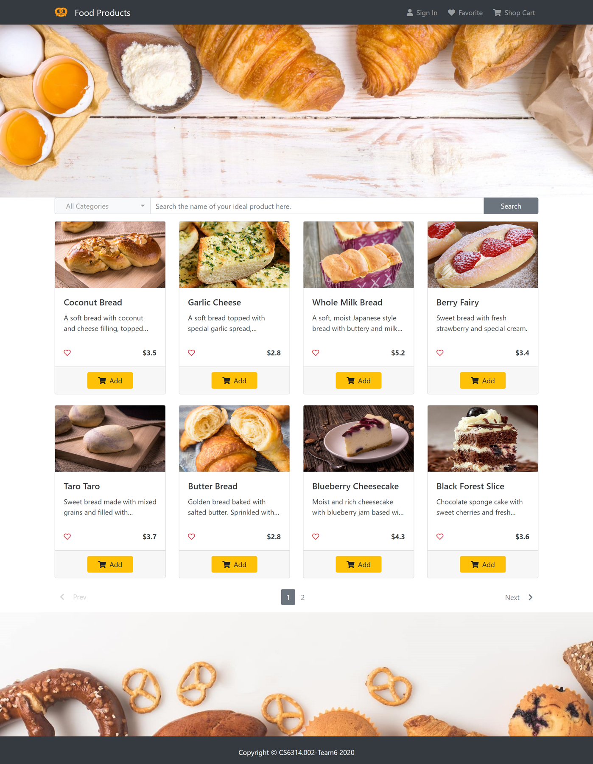

(2) Results of search and filtering (combine keywords and categories)

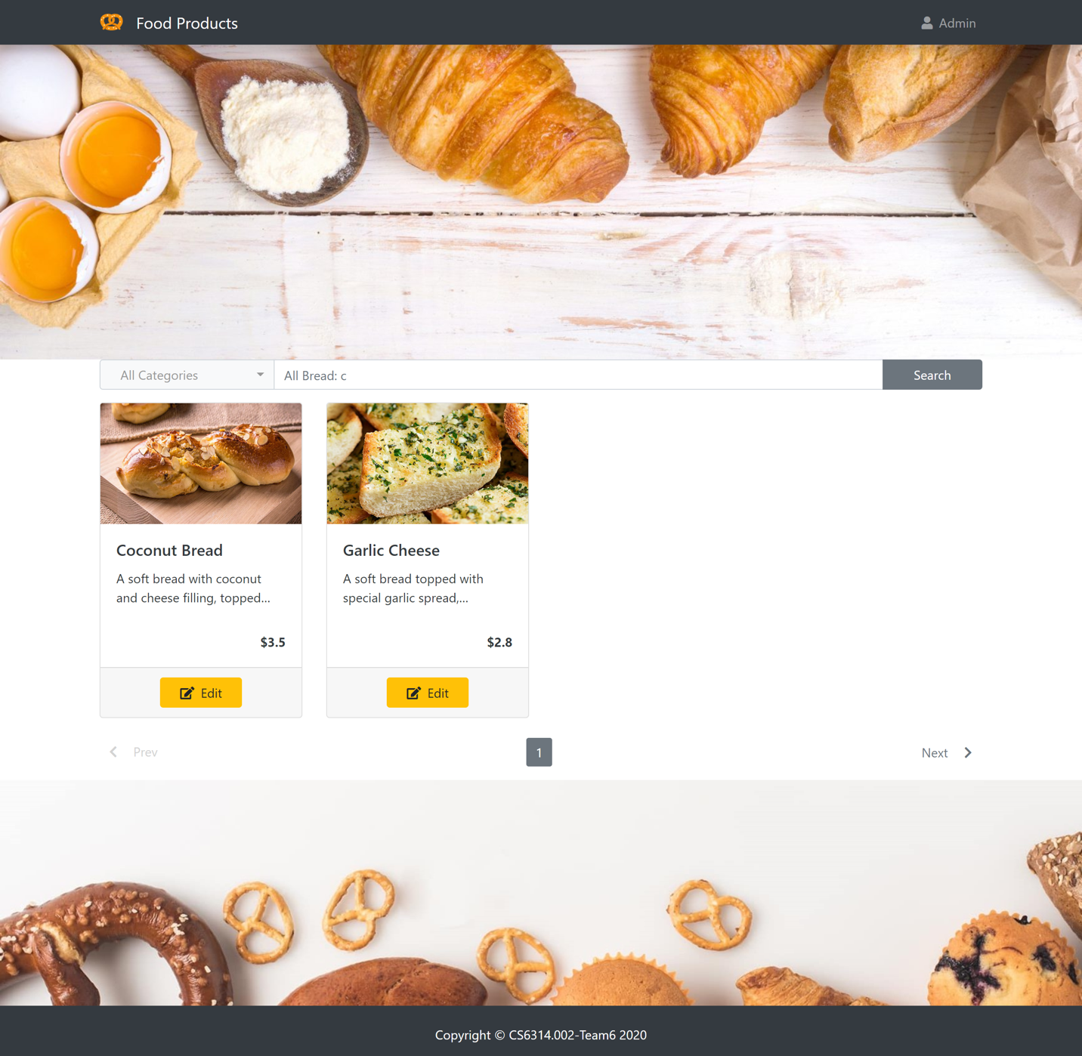

(3) Administrator create new product

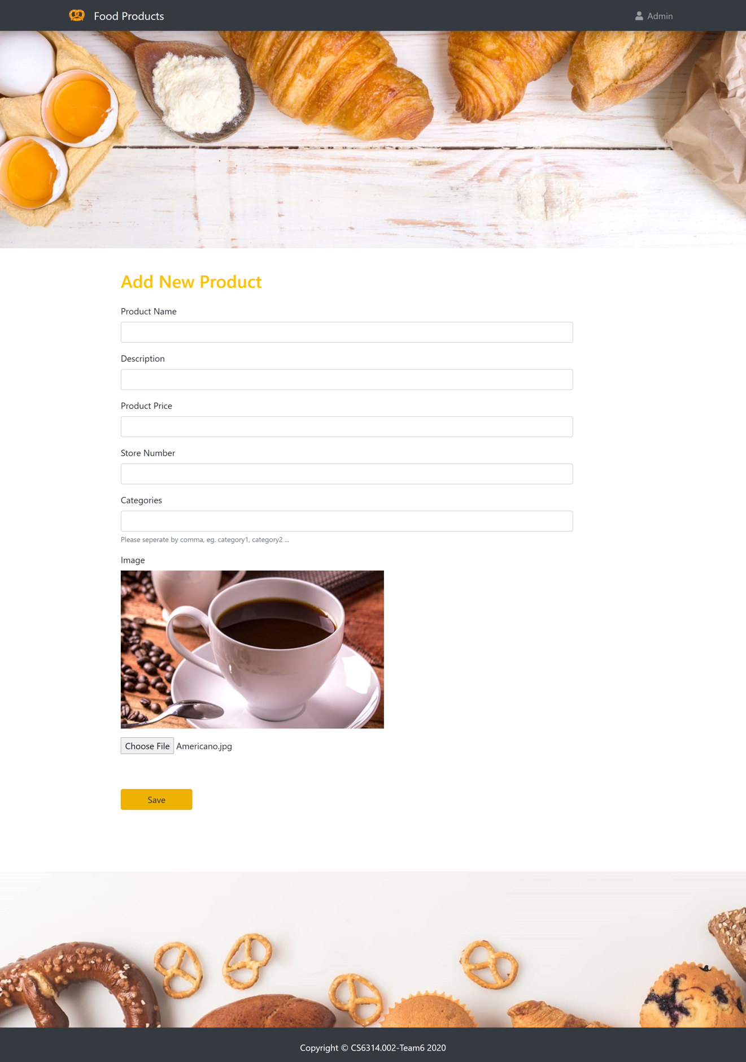

(4) User Sign up / Sign in

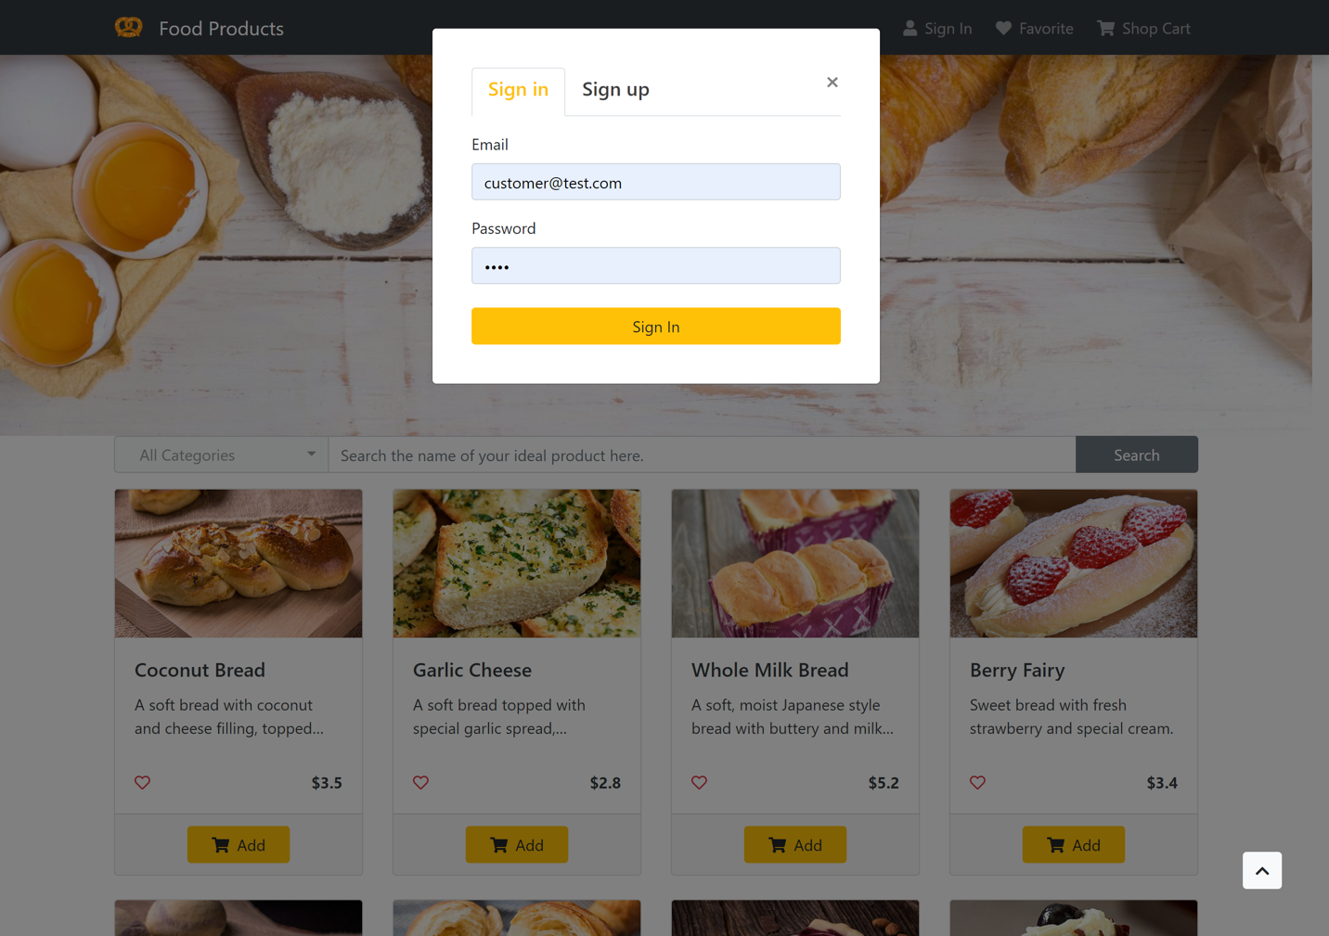

(5) Favorite

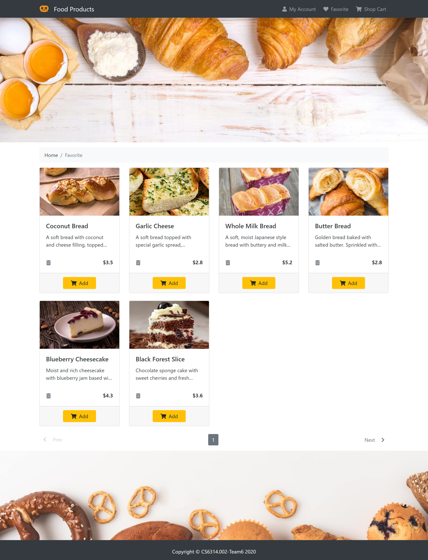

(6) User information

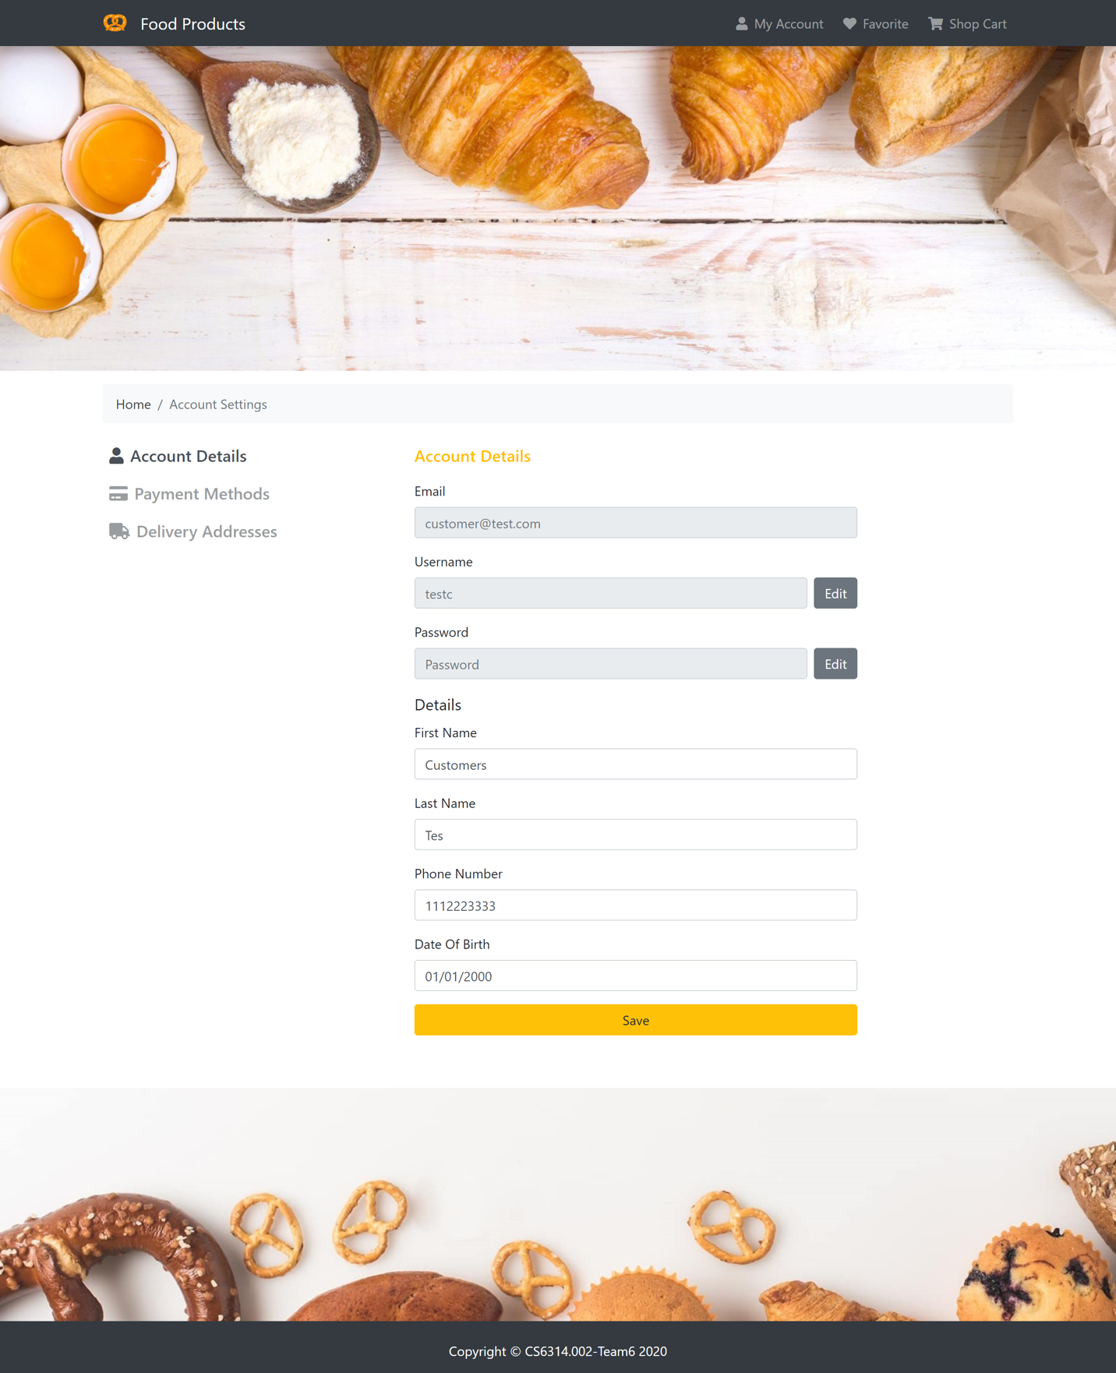

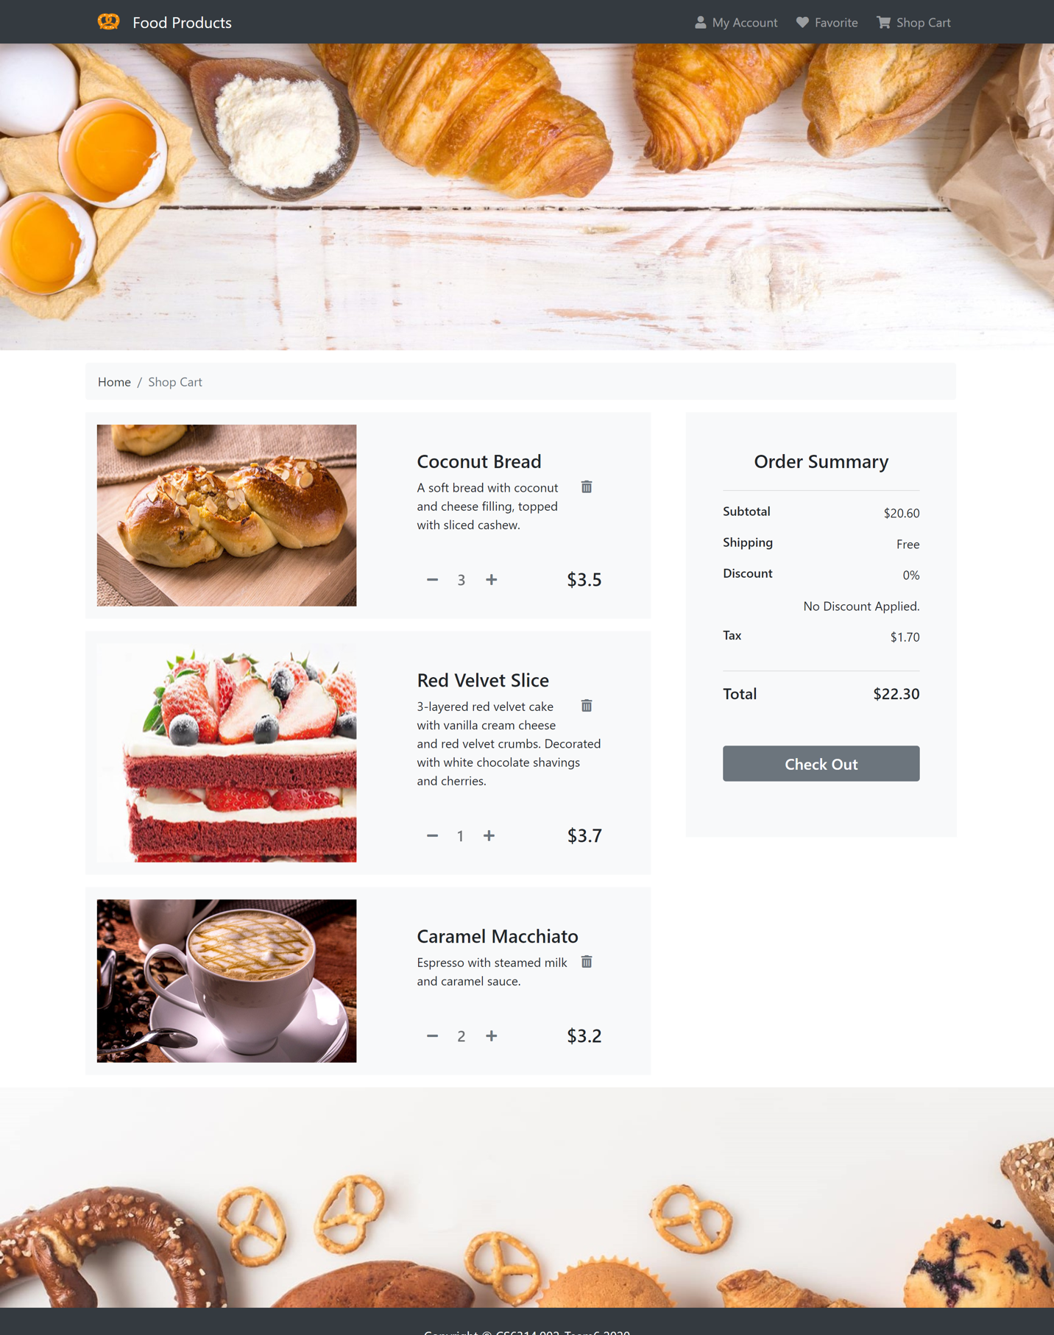(7) Shop cart

(8) Checkout

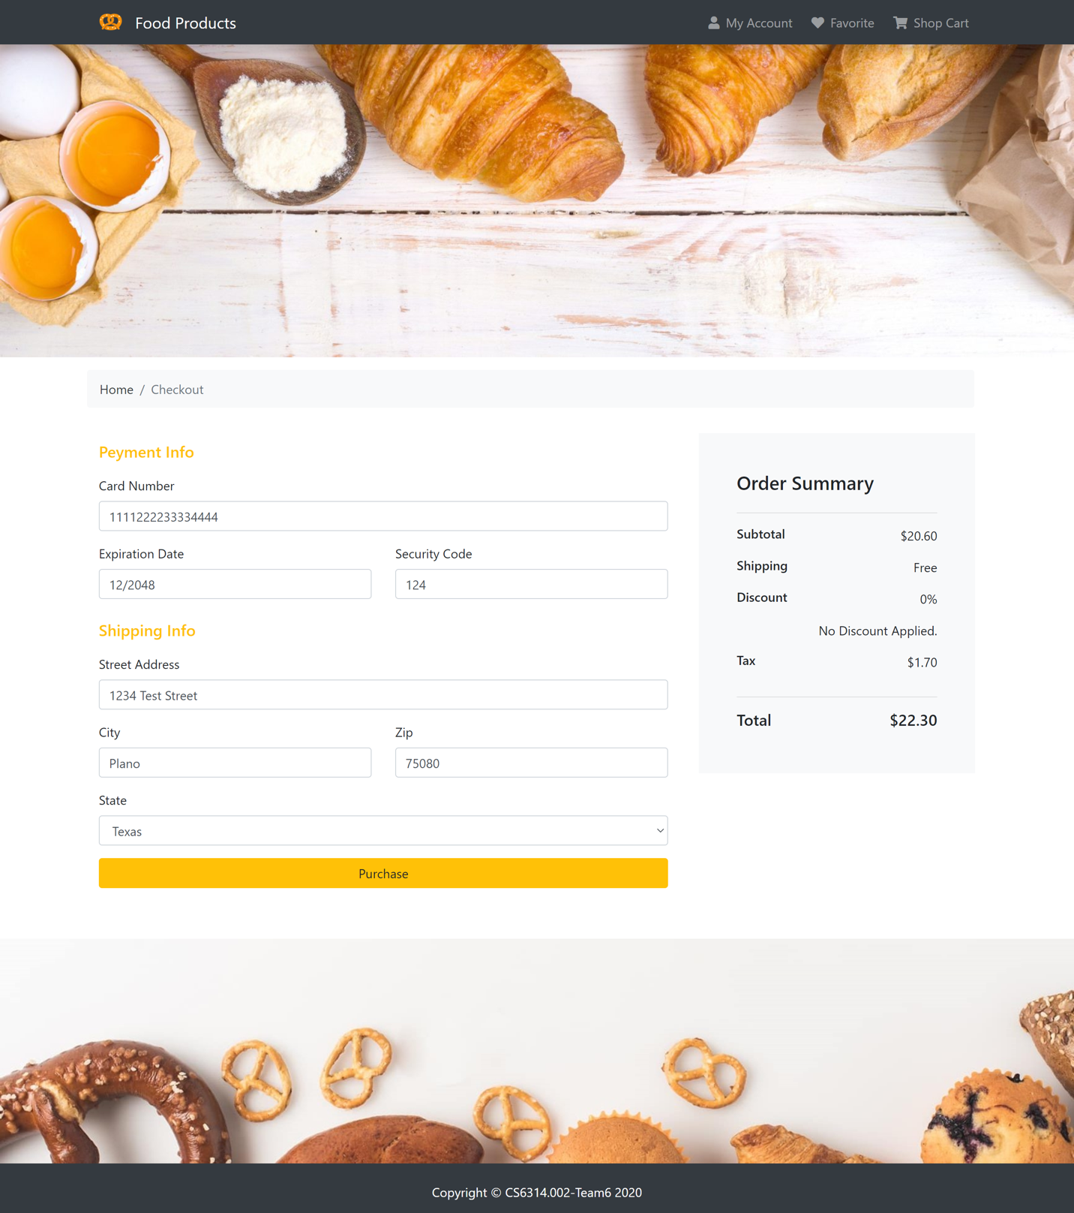

(9) Order history

